MINI-COG ™

GET THE PARTICIPANT’S ATTENTION, THEN SAY: “I am going to say three words that I want you to remember now and later. The words are

Banana Sunrise Chair.
Please say them for me now.” (Give the participant 3 tries to repeat the words. If unable after 3 tries, go to next item.)
(Fold this page back at the TWO dotted lines BELOW to make a blank space and cover the memory words. Hand the participant a pencil/pen).
- SAY ALL THE FOLLOWING PHRASES IN THE ORDER INDICATED: “Please draw a clock in the space below. Start by drawing a large circle.” (When this is done, say) “Put all the numbers in the circle.” (When done, say) “Now set the hands to show 11:10 (10 past 11).” If participant has not finished clock drawing in 3 minutes, discontinue and ask for recall items.

- SAY: “What were the three words I asked you to remember?”

_ (Score 1 point for each) 3-Item Recall Score

Score the clock (see other side for instructions): Normal clock 2 points Clock Score
Abnormal clock 0 points

Total Score = 3-item recall plus clock score 0, 1, or 2 possible impairment; 3, 4, or 5 suggests no impairment

CLOCK SCORING

NORMAL CLOCK

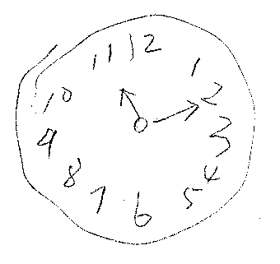
A NORMAL CLOCK HAS ALL OF THE FOLLOWING ELEMENTS:
All numbers 1-12, each only once, are present in the correct order and direction (clockwise) inside the circle.
Two hands are present, one pointing to 11 and one pointing to 2.

ANY CLOCK MISSING ANY OF THESE ELEMENTS IS SCORED ABNORMAL.
REFUSAL TO DRAW A CLOCK IS SCORED ABNORMAL.

SOME EXAMPLES OF ABNORMAL CLOCKS (THERE ARE MANY OTHER KINDS)

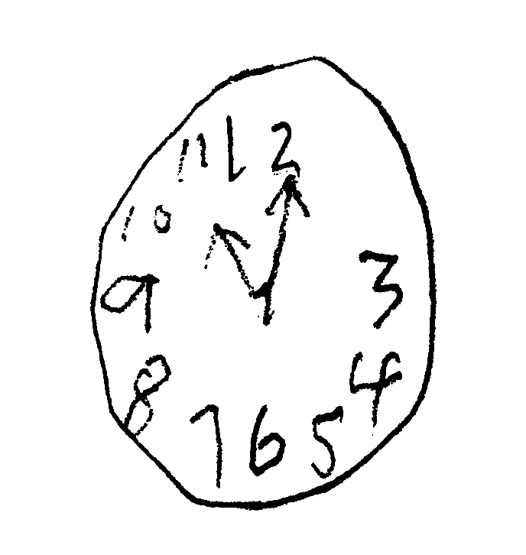

Abnormal Hands Missing Number

