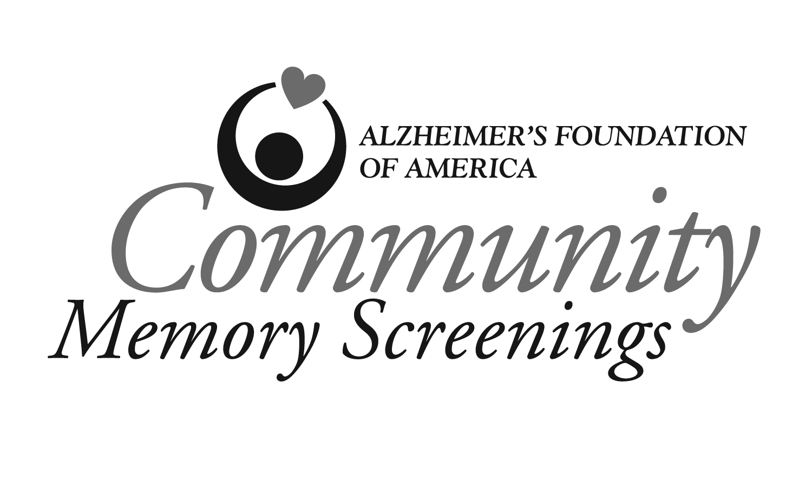

FOR IMMEDIATE RELEASE CONTACT:

Date Local: Name/Phone

AFA: Carol Steinberg/866-AFA-8484

Name of Organization to Hold Free Memory Screenings
Event Stresses the Importance of Proper Detection and Treatment

CITY, STATE—Concerned about your memory? Name of organization will be providing free, confidential memory screenings on date of screening as part of Community Memory Screenings, an initiative of the Alzheimer’s Foundation of America (AFA) designed to promote proper detection of memory problems and provide education about successful aging.
The face-to-face, noninvasive screening takes only about five to ten minutes and consists of a series of questions and tasks. It is administered by a qualified healthcare professional, such as a physician, nurse, psychologist or social worker.
Name of organization will hold the screenings from time to time at address (include city). It will also offer educational materials and (other things you are offering, if any). For more information, call phone number.
“Quote from local organization”
The Community Memory Screenings initiative is part of AFA’s ongoing efforts to raise awareness of memory concerns and educate the public about the importance of early detection and successful aging. AFA encourages screenings for adults with memory concerns, a family history of Alzheimer’s disease or who want to check their memory now and have the results for future comparison. The results do not represent a diagnosis, and AFA advises those individuals who score poorly or who have normal scores but are still concerned to follow up with their physician or another qualified healthcare professional.
A subsequent medical exam may reveal that the person has a reversible condition such as a vitamin deficiency or thyroid problem, or an irreversible disorder like Alzheimer’s disease, the most common form of dementia. Warning signs of dementia include forgetting people’s names and events, asking repetitive questions, loss of verbal or written skills and confusion over daily routines.
In addition to community memory screenings taking place across the country, myriad sites nationwide offer free, confidential screenings on AFA’s National Memory Screening Day, which will be held on November 15, 2011. For more information about memory screenings, visit www.nationalmemoryscreening.org or call 866-AFA-8484.
The Alzheimer’s Foundation of America is a national nonprofit organization headquartered in New York and made up of more than 1,600 member organizations that provide hands-on programs to meet the educational, emotional, practical and social needs of families affected by Alzheimer’s disease and related illnesses. AFA’s services include a toll-free hot line, counseling, educational materials, a free caregiver magazine, and professional training. For information, call (toll-free) 866-AFA-8484 or visit www.alzfdn.org.
##

