Association of Community Health

Nursing Educators

Innovative Teaching Strategy (ITS)
“Crisis Mapping Assignment: Service-learning with the Humanitarian OpenStreetMap Team”

Author Information:

Name: Madeleine J. Kerr
Title: Associate Professor
Credentials: PhD, RN
Co-Authors: _
Organization: University of Minnesota, School of Nursing
Email Address: kerrx010@umn.edu
Office Phone: 612-625-2669
Address: 5-140 Weaver Densford Hall
308 Harvard St. SE
City: Minneapolis
State: MN
Zip: 55455

Association of Community Health Nursing Educators Teaching Strategy

1. Title of Teaching Strategy: Crisis Mapping Assignment: Service-learning with the Humanitarian OpenStreetMap Team

2. Date of Submission: July 14, 2015, revised Oct. 1, 2015

3. Topical Area:

e. Disaster Nursing/Bioterrorism

j. Global Health

i. Emerging Pandemic Diseases

ii. International Public Health Nursing

p. Information and Healthcare Technologies

4. Public Health Nursing competencies and standards:

ACHNE Public Health Nursing Core Knowledge and Basic Competencies

3. Community/population assessment

9. Information and health care technology

11. Global health

5. Learner Level(s): RN to BSN, Undergraduate
6. Learner Setting(s): Online or web-based modules, independent study.
7. Strategy Type: Reflective activity, Paper assignment.
8. Learning Goals/Objectives:
At the end of this assignment, students will be able to:
- Generate new electronic data from satellite imagery of a geographic location experiencing a public health crisis. (Bloom’s “Synthesis”/ new “Create” level)
- Reflect on their shared sense of responsibility in addressing a global health issue through crisis mapping. (Bloom’s “Evaluate” level)
- Evaluate the contribution of OpenStreetMap to the understanding of global health issues and disaster response. (Bloom’s “Evaluate” level)

9. Estimated time for the activity: 2 hours
10. Strategy Overview: Students prepare by learning to be volunteer mappers online with the Humanitarian OpenStreetMap Team http://hotosm.org/ . OpenStreetMap is a freely available editable map of the world created by a community of volunteers https://www.openstreetmap.org/about. As volunteers, students contribute new map data online for a small geographic area they select from a list of locations experiencing public health crises. They write a brief paper including a description of the volunteer work they completed, an analysis of the geographic location, and a reflection on their mapping experience.

11. Detailed Strategy Directions: Please see attached “Crisis Mapping Assignment”
a. Strategy Materials/Resources: Access to the internet.

b. Website Links: Detailed instructions from the assignment are copied below:
- Create an OpenStreetMap account (free): http://www.openstreetmap.org
- Check out MapGive's tutorial video:
http://mapgive.state.gov/learn-to-map/
- Select a task “In Progress” from OpenStreetMap Tasking Manager http://tasks.hotosm.org/
c. Methods for evaluating student learning: Student learning is evaluated through a 3-4 page student paper. The assignment rubric is copied below:

Grading criteria | Points
Project Description. Full description of the mapping project and the map features you contributed. | 6
Clear display of screen shot showing the area of your data entries | 4
Analysis. Insightful assessment of the community based on map features available. | 6
Reflection Thoughtful commentary on your experience as a volunteer mapper. | 4
Total | 20

12. Comment on overall success of this teaching strategy
The strategy was implemented successfully as a pilot in an undergraduate Health Informatics course in 2014-2015. Student papers indicated that they readily followed the assignment instructions using the online resources to complete the volunteer mapping, e.g. “I was extremely impressed with how easy it was to use OpenStreetMap”.

Evaluation of the learning objectives follows.
- Generate new electronic data from satellite imagery of a geographic location experiencing a public health crisis. (Bloom’s “Synthesis” /new Bloom’s “Create” level)
The first time offered as an alternate assignment in Fall 2014, 11 students chose to do the Crisis Mapping Assignment out of 83 (13%). The second time in Spring 2015, 13 out of 65 (20%) completed it. As a group, the students contributed approximately 48 hours of volunteer mapping of areas suffering from Ebola or Cholera in Africa.
- Reflect on their shared sense of responsibility in addressing a global health issue through crisis mapping. (Bloom’s “Evaluate” level)
Students expressed a sense of wonder at this technology that allowed them to feel involved with a greater humanitarian effort across the globe, e.g. “It felt surreal to be able to help volunteer with an initiative in Liberia from my living room” and “The main reason I enjoyed participating in this OpenStreetMapping project was due to the fact that it incorporated technology with humanitarian work. I truly hope to devote part of my career to a humanitarian organization..”

13. Additional References: Used in the development of the strategy:

Hodson, H. (2014). Mapping in a crisis. New Scientist, 222(2964), 19.

Crisis Mapping Assignment:

Service-learning with the Humanitarian OpenStreetMap Team

Purpose
The purpose of this individual assignment is to assist in the humanitarian response to a public health crisis by mapping features such as roads, paths, and buildings. This activity with the Humanitarian OpenStreetMap Team will prepare you for future use of location-based technologies in local and global public health.

Learning Objectives
At the end of this assignment, students will be able to:
- Generate new electronic data from satellite imagery of a geographic location experiencing a public health crisis.
- Reflect on their shared sense of responsibility in addressing a global health issue.

Due Date
Week X: Check schedule for exact due dates.

Format
The paper should be 3-4 pages including a title page, submitted as a Word (.doc, .docx) or Rich text file (.rtf), 1 inch margins, in Courier, Arial or Times New Roman 12 pt font. No references are required. First person “I” is fine because you are describing your experience and reflections.

Submission
Submit this assignment to the appropriate dropbox in the week assigned.

Grading criteria | Points
Project Description. Full description of the mapping project and the map features you contributed. | 6
Clear display of screen shot showing the area of your data entries | 4
Analysis. Insightful assessment of the community based on map features available. | 6
Reflection Thoughtful commentary on your experience with the mapping program. | 4
Total | 20

Crisis Mapping Detailed Instructions

Paper outline:
1) Project Description. Describe the task you chose to complete for your project referring to the specific OpenStreetMap Task Manager Job number. Describe the location and the map features you contributed. Include a screen picture of your mapping data using instructions below.
2) Analysis. Analyze the features available on the map. What inferences can you make about the communities living there based on the existing map? (e.g. rural or urban)
3) Reflection. Reflect on your Humanitarian OpenStreetMap experience. What did it mean to you? Write about successes or challenges you had in using the mapping application.

Detailed instructions:
- Create an OpenStreetMap account (free): http://www.openstreetmap.org
- Check out MapGive's tutorial video:
http://mapgive.state.gov/learn-to-map/
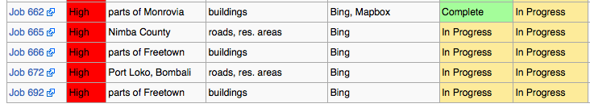
- Select a task “In Progress” from OpenStreetMap Tasking Manager http://tasks.hotosm.org/

- Do the mapping requested of volunteers for up to 2 hours maximum. If you don’t finish a square, make note of what’s left, or simply say it’s not finished. Don’t worry, your work will be validated by another volunteer so just do the best you can. Save your work, commenting on the task as prompted in the tutorial video.
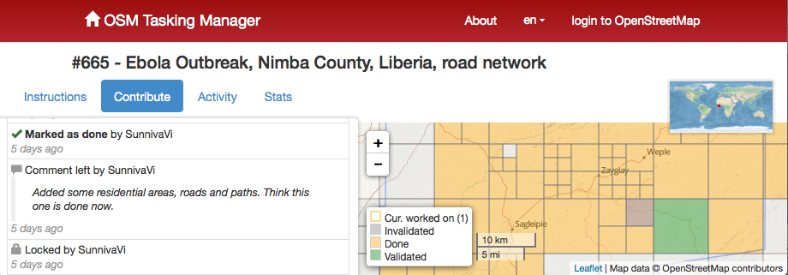
- Take a screen shot of your section of map http://www.take-a-screenshot.org/ and submit the picture file with your assignment (sample below).

